MR. VERNE HARNISH “GROWTH GUY”

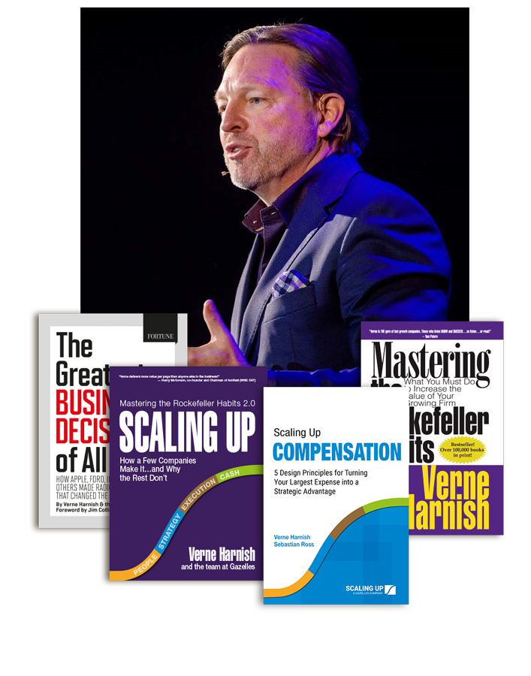
AUTHOR:

Scaling Up Compensation: 5 Design Principles for Turning Your Largest Expense into a Strategic Advantage
Scaling Up: How a Few Companies Make It…and Why the Rest Don’t (Rockefeller Habits 2.0)
The Greatest Business Decisions of All Time: How Apple, Ford, IBM, Zappos, and others made radical choices that changed the course of business
Mastering the Rockefeller Habits: What You Must Do to Increase the Value of Your Growth Firm

TESTIMONIALS:
"Verne is THE guru of fast growth companies. Those who listen GROW and SUCCEED . . . so listen . . . or read!"
Tom Peters
“Verne is more committed to helping companies grow than any other person on the planet. Really. He’s also radically practical in his approach and that is reflected throughout this terrific book.”
Patrick Lencioni, best-selling author of The Five Dysfunctions
of a Team and The Advantage
“Scaling Up addresses the second half of the venture ball game, something often lost in all the hoopla about incubating disruptive innovation during the first half. Half-time scores don’t matter—it’s all about how you finish the game. So get yourself into Verne’s locker room for a great half-time pep talk.”
Geoffrey Moore, Author, Crossing the Chasm
“Imagine walking into a library and finding one book that captures the ideas of all the books in the library. Scaling Up is that business book. You will not have to go any farther.”

Jack Stack, founder and CEO of SRC Holdings; best-selling author of
The Great Game of Business and A Stake in the Outcome

BIO:
Verne Harnish is founder of the world-renowned Entrepreneurs’ Organization (EO), with over 16,000 members worldwide, and chaired for fifteen years EO’s premiere CEO program, the “Birthing of Giants” held at MIT, a program in which he still teaches today.
Founder and CEO of Scaling Up, a global executive education and coaching company with over 200 partners on six continents, Verne has spent the past four decades helping companies scaleup.
He’s the author of multiple bestsellers including Mastering the Rockefeller Habits; The Greatest Business Decisions of All Times," for which Jim Collins wrote the foreword; Scaling Up (Rockefeller Habits 2.0) which has been translated into 23 languages and has won eight major international book awards including the prestigious International Book Award for Best General Business book; and his latest book Scaling Up Compensation.
Verne serves on several boards including vice chair of The Riordan Clinic; co-founder and chair of Geoversity; and board member of the social venture Million Dollar Women. A private investor in many scaleups, Verne enjoys piano, tennis, and magic as a card-carrying member of the International Brotherhood of Magicians.

